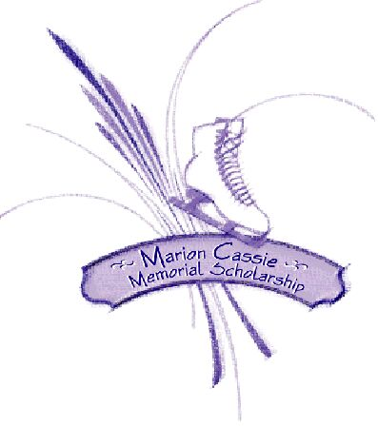
2022 Marion Cassie Memorial Scholarship
Mission Statement: To sustain the memory of longtime friend and contributor to the sport of figure skating by implementing her desire to establish a scholarship fund for Uxbridge skaters.
A $1,000 scholarship is awarded annually to a graduating student pursuing their first year of post-secondary education at an accredited institution. Applicants must have a proven record of volunteerism, especially within the skating community, and be a home club member, past or present, of Uxbridge Skating Club.

Criteria & Conditions
Please read carefully. If you have any questions, contact Linda Story (lindastory27@hotmail.com) or at 905-806-0159.

- Current or former Home Club member of the Uxbridge Skating Club (minimum two full skating years); may have been a member of any other Skate Canada club in other years;
- History of volunteerism on behalf of Uxbridge Skating Club; details are important as particular emphasis is given to volunteerism;
- History of community service or volunteerism with other organizations; details are important as particular emphasis is given to volunteerism;
- Residency and location of high school are not issues. Home Club skaters or former Home Club skaters may reside outside the Uxbridge area;
- Scholastic achievement & goals
- not necessarily highest grades
- graduating student enrolling in university, community college, or technical institution
- A delay in enrollment is not an impediment, as long as the applicant is registered for their first year of post-secondary education in the current year; the applicant may have taken a year or more off between graduation and enrollment;
- Financial or other extenuating circumstances may be considered, if the applicant chooses to disclose these in his or her letter.
IMPORTANT !
Due to COVID-19, the application deadline has been shortened to allow sufficient time for the Selection Committee to review and choose this year’s recipient and to meet USS requirements for announcement of awarded scholarships. We apologize for the short turnaround.
Please give strict attention to deadline dates for required documentation. The Scholarship Committee reserves the right to withdraw any applications that do not meet document and deadline requirements. Missing Documentation = Disqualified Application.
A Certificate of Commitment will be presented to the successful applicant at the Graduation Ceremony. However, funding will only be released on presentation of proof of paid tuition, which must be received no later than September 1st of the scholarship year.
2022 Marion Cassie Memorial Scholarship Committee

2022 Marion Cassie Memorial Scholarship
Application for Consideration - Deadline May 13, 2022
(for 1st year accredited post-secondary applicants only – University, Community College, Technical Institution)

I am applying for consideration of the Marion Cassie Memorial Scholarship. I have read and understand the attached criteria and conditions. The following information and required supporting documents are provided to confirm my eligibility.
Applicant's Name:
Full Address:
Telephone Number: | E-Mail Address:
High School Attended: | Guidance Contact:
Post-Secondary Institution Applied For:
USC Home Club Member Years: | Coach:
Highest Tests Passed (list all disciplines):
Program Assistant? Yes No How many years?
Other USC Volunteer Activities (can be listed on separate page):
Other Community Activities (can be listed on separate page):
Are you currently enrolled in any Skate Canada skating program? Yes No | Is your amateur status an issue? Yes No

The above information regarding my past skating history has been verified with the Uxbridge Skating Club, as attested by the signature below of the current club president. All required documents have been attached to this application. Note: if you need help with the required information, please contact Linda Story (lindastory27@hotmail.com or at 905-806-0159).

_____________________________ ______________________________
Date APPLICANT'S SIGNATURE

USC PRESIDENT’S CONFIRMATION REQUIRED: This year, in lieu of an actual signature from the Club President, we will accept his/her email confirmation, attesting to the accuracy of the above information. An email address for the Club President will be provided to applicants on request to lindastory27@hotmail.com. Be sure to include “MCMS Application” in the subject line.

required Attachments
INCOMPLETE APPLICATIONS (those with missing documents) WILL BE DISQUALIFIED.
- Proof of Home Club membership for a minimum of two full years with the Uxbridge Skating Club (USC)
(copy of Skate Canada membership cards or written confirmation from Skate Canada);
- Proof of highest tests passed (copy of Test Certificates in each discipline or Skate Canada membership card which indicates the applicant’s highest tests);
- Letter of Reference from a member of the Uxbridge skating community (one only please) confirming applicant's skating history, including volunteerism (may be a current or former USC director, coach, or Skate Canada official);
- Copies of Award Certificates or Official Citations for volunteerism (if applicable; excludes all media articles);
- Letter of Reference from a high school teacher, outlining school achievements and participation;
- Letter from applicant stating current goals and the reasons he or she should be considered for the scholarship;
- Photo of applicant (prefer picture as skater, but will accept other current head-and-shoulders picture)
- Copy of Offer of Admission; this may follow scholarship application but must be received by June 1, 2022;
- Proof of Paid Enrollment must be received no later than September 1, 2022; both of these last two documents can be emailed to Linda Story (lindastory27@hotmail.com) by their respective required due dates.
IMPORTANT: All documents must be received by the listed deadlines, otherwise the scholarship application will be considered withdrawn. To ensure fairness to all applicants, ONLY the requested documents will be considered.
Please submit the completed application no later than May 13, 2022 together with required documents to:
karen gillespie, Guidance Office, Uxbridge Secondary School (905) 852-3391
Application and documents may be emailed to karen.gillespie@ddsb.ca (PDF format only). Request a Confirmation of Delivery.

